BIOC 455
Lecture #2 – Introduction to the CNS
Lecturer: Dr. Cermakian – January 8th, 2007

NOTE: This NTC is meant to be used as a study aid to supplement your own class notes. Hence, not all of the text or diagrams contained in the lecture slides will be reproduced here.

Please send any comments or questions about NTCs to either Wanda or James through e-mail at u3.represent@gmail.com .

Last day:
- Covered the general organization of the Central Nervous System (CNS)
- The definition, structure and function of neurons

Today:
- Continue the general organization of CNS: meninges and the blood brain barrier
- The definition, structure and function of neuroglia (glial cells)

MENINGES: composed of different layers that serve to protect and nourish the brain.
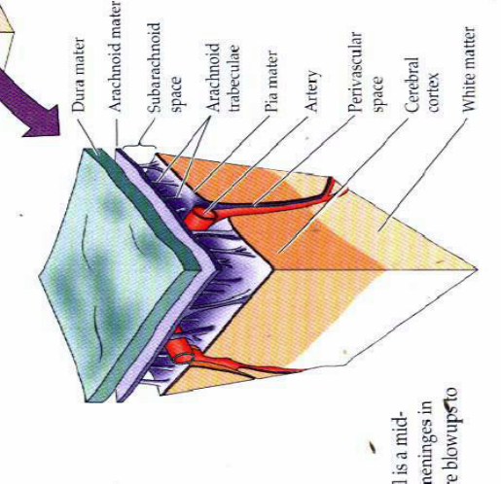
Dura mater: Tough skin

Arachnoid mater: Thin skin

Pia mater: Very thin skin layer

Subarachnoid space: Located between Arachnoid mater and Pia mater. Contains Cerebrospinal Fluid (CSF) and blood vessels to provide nutrients and other small molecules to the brain.

Cerebrospinal fluid (CSF)
- Protects brain from mechanical trauma
- Balances electrolytes and proteins
- Maintains pressure in ventricals (cavity space in brain)

Contents of CSF:
- Continually renewed
- Liquid buffer of many molecules: vitamins, proteins, neurotransmitters, electrolytes, vitamins, hormones, etc.
  - Components must have specific concentration range or else can lead to disease
  - Can take fluid from spine and test for diseases (such as narcolepsy) by looking at the balance of the CSF components

BLOOD BRAIN BARRIER (BBB)
- Everywhere in brain, with a few exceptions
- Consists of tight junctions that prevent macromolecules and toxins from passing through the blood and into the brain.

Molecules that pass the BBB:
- H₂O
- Lipid-soluble molecules (ex: alcohol, valium, nicotine)
- Carrier proteins for glucose, amino acids, choline, vitamins, and thyroid hormones.

CELL TYPES
- Neurons → covered last day
- Neuroglia (glial cells)

NEUROGLIA:

Different from neurons in that they DON’T HAVE:
- Synaptic contacts
- Ability to divide

TYPES OF NEUROGLIA:

I Macroglia

(i) Astrocytes
- Very abundant in brain, 20% of brain volume
- Can tag specifically using GFAP and locate in a brain section (experimentally)

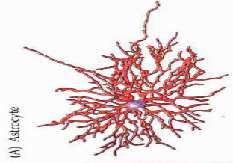
Structure:
- Looks like a star; cell body with radial projections

Function:
1) Remove and regulate substances that should not be there:
- pH regulation; Detoxification

2) Induction of tight junction in the blood brain barrier

3) Migration of neurons during development

4) Glucose metabolism

5) Response to infection and injury:
- Cytokine synthesis; Antigen presentation

(ii) Oligodendrocytes
- Make myelin sheath in CNS
- Have similar mechanistic process to make myelin as Schwann cells (in PNS)
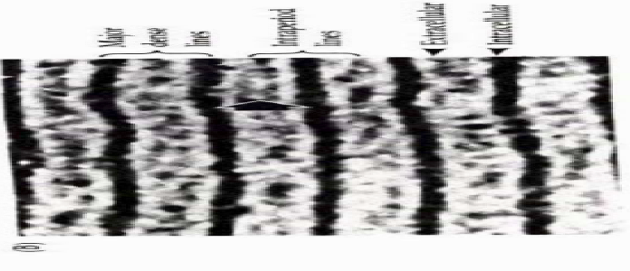
Myelin synthesis in PNS:
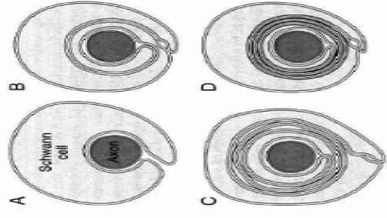
Left: Schwann cells grow and make turns around the axon, thus creating layers.

Right: Electron microscopy of myelin cross-section
- Major dense lines (dark space) = Intracellular space
- Intraperiod lines (light space) = Extracellular space

MYELIN

Constituents:

70-85% Lipid

15-30% Protein: major and minor proteins
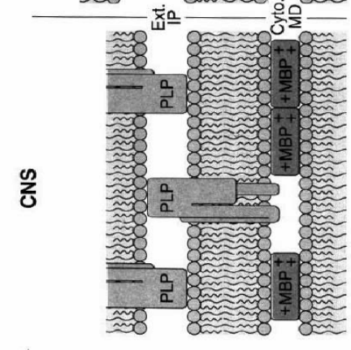
- Major proteins:
  - MBP: Intracellular protein that packs myelin. It is positively charged, therefore it can bind the negatively charged membrane and pack it to adjacent membrane.
  - PLP: Protein that spans two membrane layers and decreases the extracellular space between Schwann cell layers.

Function:

1) Electrical insulator:
- Facilitates conduction
- Sites not covered by myelin = Nodes of Ranvier (sites of depolarization so that the action potential signal can travel).

To increase speed of signal:
- Widen axon
- Increase the amount of myelin such that signal can jump Nodes of Ranvier.

2) Inhibition of axon regeneration by myelin proteins
- Protein in CNS generated by myelin, inhibits re-growth of axons if they have been severed.
- In PNS, if you severe and axon, it WILL regenerate.

II Microglia
- Important, abundant in brain
- Removes cell debris

III Ependymal cells:
- Help cells move

